How do we have **WIFI** in the middle of this desolate hellscape???

**Black Rock City** needs reliable Internet connectivity for several organizational functions (ticketing, logistics, medical, public safety, etc.).

The **Burning Man Network Operations Team** provides this through a variety of technologies that are designed to operate in this complex environment and obtain connectivity back to “civilization” (commercial Internet fiber peering and transit).

This is a challenging but critical function, one of many parts of the **incredible behind-the-scenes engineering effort** that happens each year to make Burning Man possible.

The Network Operations Team (thanks Cat -^..^- !!) **provides surplus bandwidth as a gift to camps**, to support their art and to offer to participants.

Connectivity is blanketed across the playa using a series of **directional point-to-multipoint radios on a 60ft tower near Center Camp**. These radios use a special protocol similar to (but not identical to) 5ghz WiFi to optimize for reliable distribution to camps:

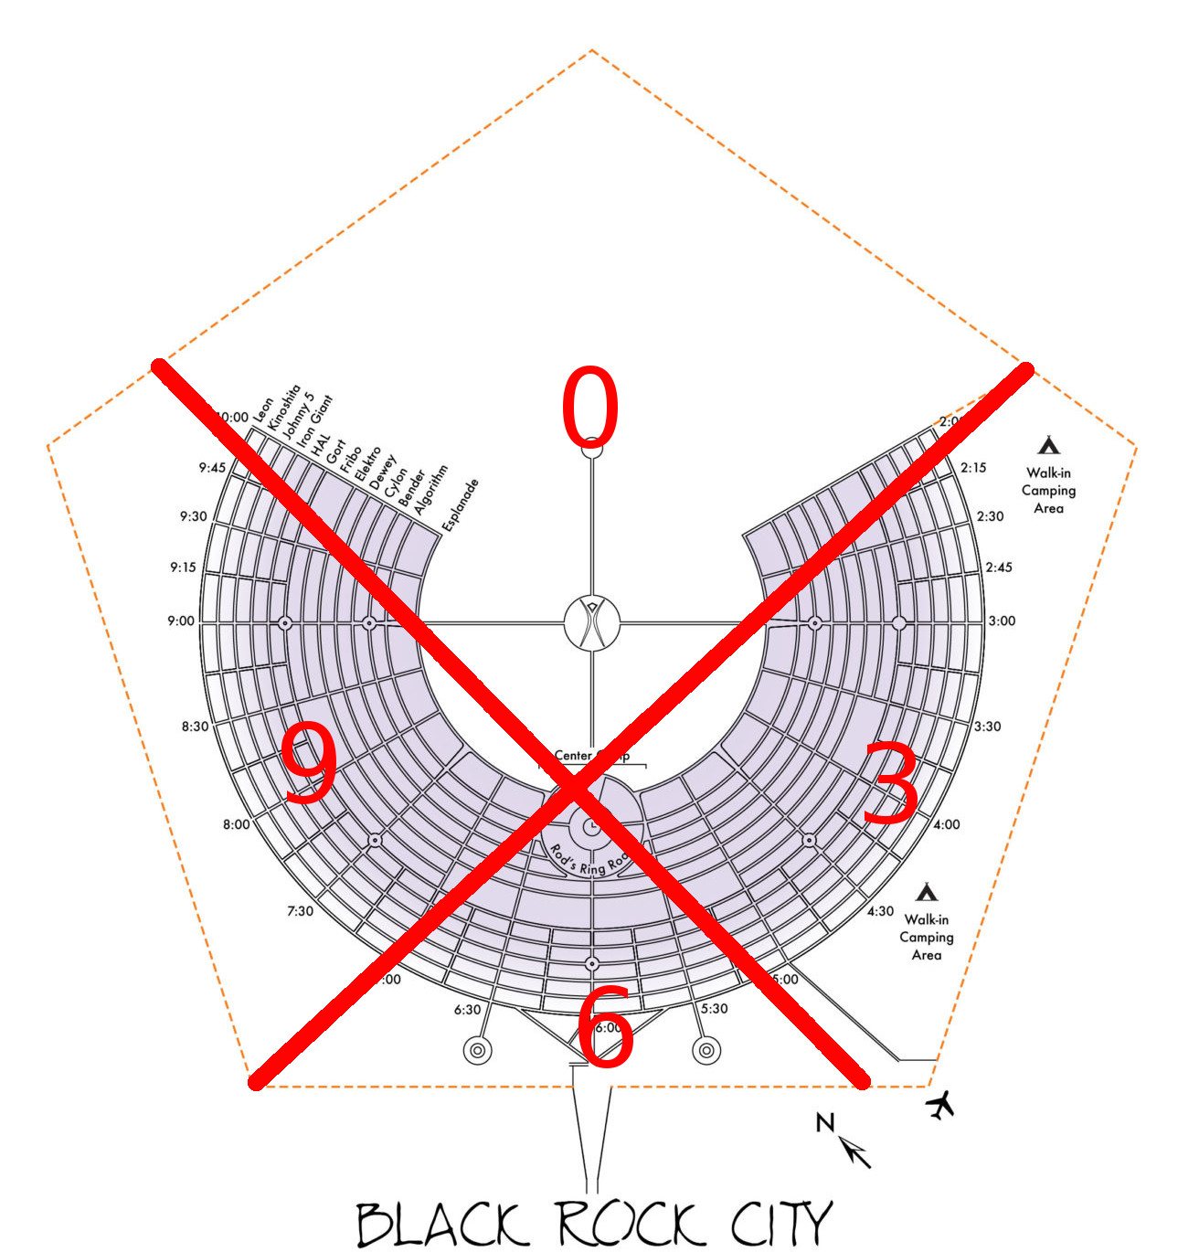

Camps that want connectivity must:

**1.)** Obtain and configure a compatible radio

**2.)** Safely obtain line-of-sight to the Center Camp tower

**3.)** Provide the radio with a reliable source of power

**4.)** Provide some mechanism (2.4ghz wifi, etc…) for distributing connectivity within their camp.

**Engineering in this complex environment is part of our artistic expression and our gift to fellow participants.**

**We’re glad that you’ve stopped by!**